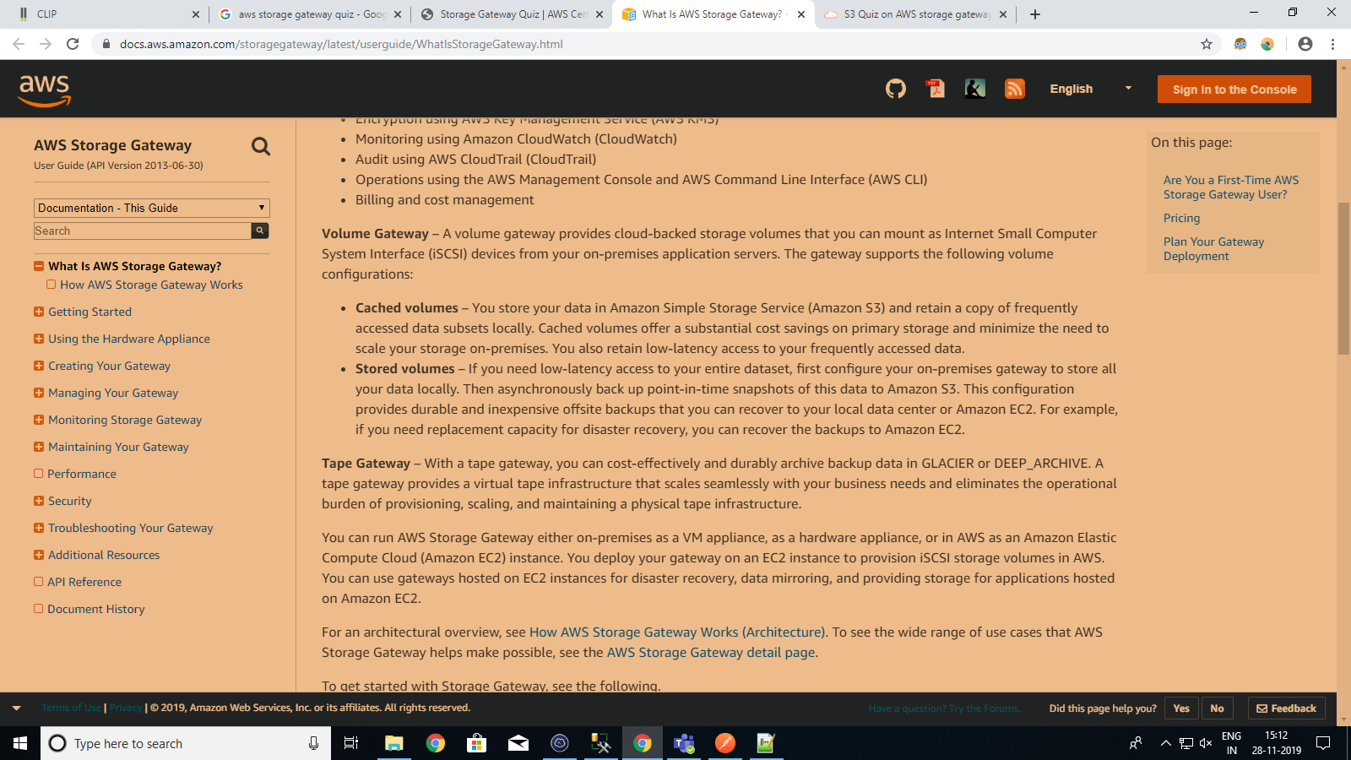

Storage Gateway flashcards :

<https://quizlet.com/295279179/aws-storage-gateway-flash-cards/>

Storage Gateway Quiz:

<https://acloudxpert.com/storage-gateway-quiz/>